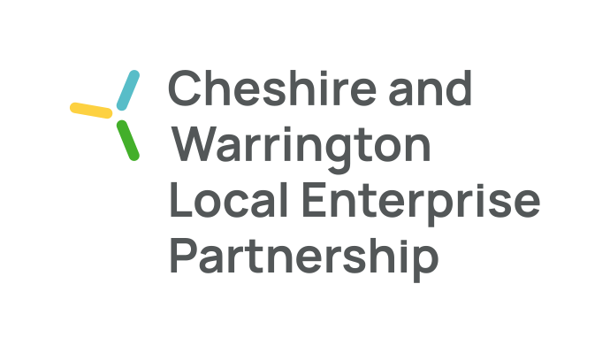
Notes for Engagement Board Meeting 25th July 2022

The following people attended the meeting:
- Maggie Chen (Chair)
- Katie McConnell
- Joe Toward
- Connor Diskin
- Kirstin McCallum

Apologies:
- Yulanda Duff

The main purpose of the meeting is to:
- Receive updates on recruitment and mentorship
- Discuss updates on the North West Net Zero Youth Network event

Meeting Notes

20.15 hrs Welcome and apologies (5 mins)
- Welcome by Maggie

20.20 hrs Update from Kirstin (15 minutes)
- Recruitment for EB: Marketing Cheshire is caught up with other work and does not have capacity to complete the recruitment video at the moment. They are unlikely to resume work on this until September.
- Mentorship update: previously the EB decided that it would be ideal for each board member to have a mentor from another board, and the main board agreed that this would be a fantastic opportunity for a two-way mentorship programme. Since then, Maggie created a document outlining the programme and shared with Kirstin. Kirstin confirms that this has now been sent out to all board members. EB members should expect to hear from possible mentors in the coming weeks.

20.35 hrs North West Net Zero Youth Network (20 mins)
- Connor has replaced Maggie as the liaison for this project as Maggie could not make the event date of 1 October.
- The event will be held on 1 October, likely in Salford. Crewe was considered due to its connectivity and the fact that Cheshire is often overlooked. However, finding a venue was difficult.
- The event will host 100 young people, split into 5 groups of 20. There will be 5 themes, 1 theme per group.
- The themes are: 1) green jobs and skills, 2) transport, 3) energy, 4) business & industry – a green economy, 5) green spaces & nature-based solutions. These themes came from combining the sustainability priorities of the participating regions in the North West.

AOB
- Joe will be leaving the area in September, and therefore, leaving the board as well.
- The next official meeting will be in September, however, members of the board will aim to meet in person in August. Ideally, end of August.
Meeting end.

