Cheshire & warrington LEP covid-19 DASHBOARD

21-27 September 2020
ECONOMIC CONDITIONS

Local Vacancies EMSI Cheshire and Warrington
1% 7% 3.3% 3% 3.2% 2.5%
Job postings in the week Nurses Care workers Bookkeepers IT/software Storage
20,108 to 20,317
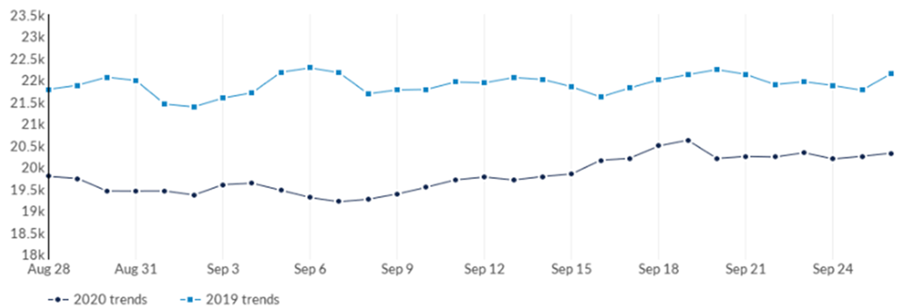

Universal Claimant Count August DWP

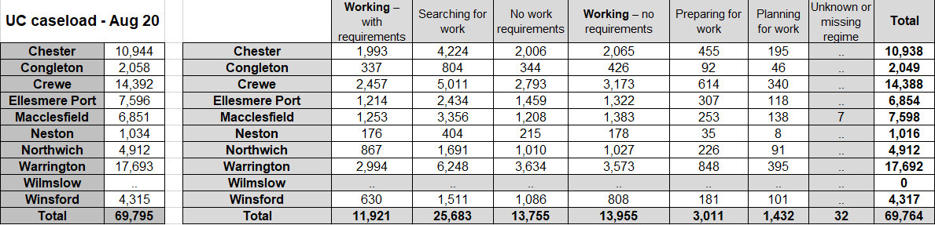

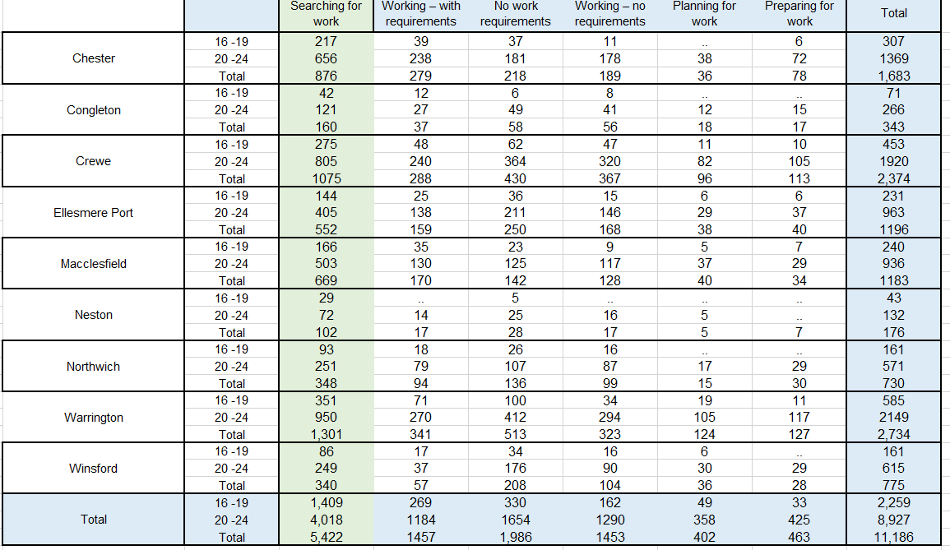
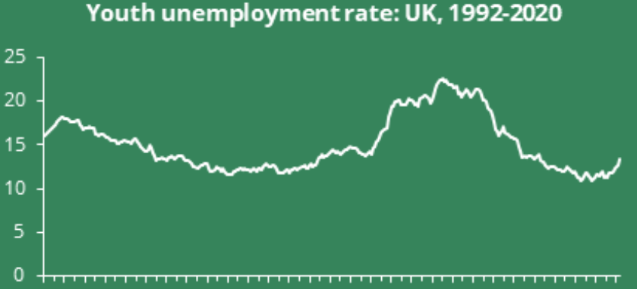
Universal Credit Local Youth Breakdown August DWP Youth Unemployment National

GOVERNMENT SUPPORT HM Treasury
National take up reported 20 September 2020
FUND | No. Application | No. Approved | Value Approved
CBILS | 142,076 | 66,585 | £15.45bn
CLBILS | 992 | 566 | £3.84bn
Bounce Back Loan | 1,552,727 | 1,260,940 | £38.02bn
Future Fund | 1,072 | 711 | £720.0m

Coronavirus Job Retention Scheme Commons Library, HMRC
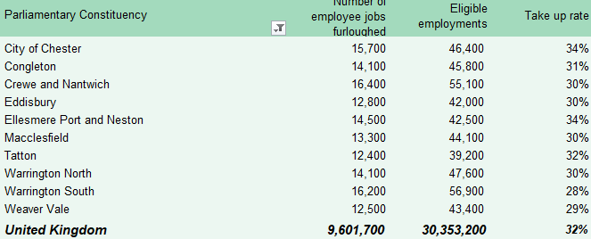
Retail, Hospitality and Leisure Grant BEIS

97% 97% 95%
CE CWAC Warrington

Discretionary Funding Local Authorities

100% 100% 100%
CE CWAC Warrington

LIQUIDATIONS AND DISSOLUTIONS Bureau van Dijk INCORPORATIONS Bureau Van Dijk
Companies with a registered address, primary trade address or trade address in Cheshire and Warrington
September 1070  Cheshire East 401  Cheshire West and Chester 324  Warrington 345  69%on 2019  100% on 2018 |  | September 944  Cheshire East 326  Cheshire West and Chester 351  Warrington 267

BUSINESS SENTIMENT FSB BREXITBCC
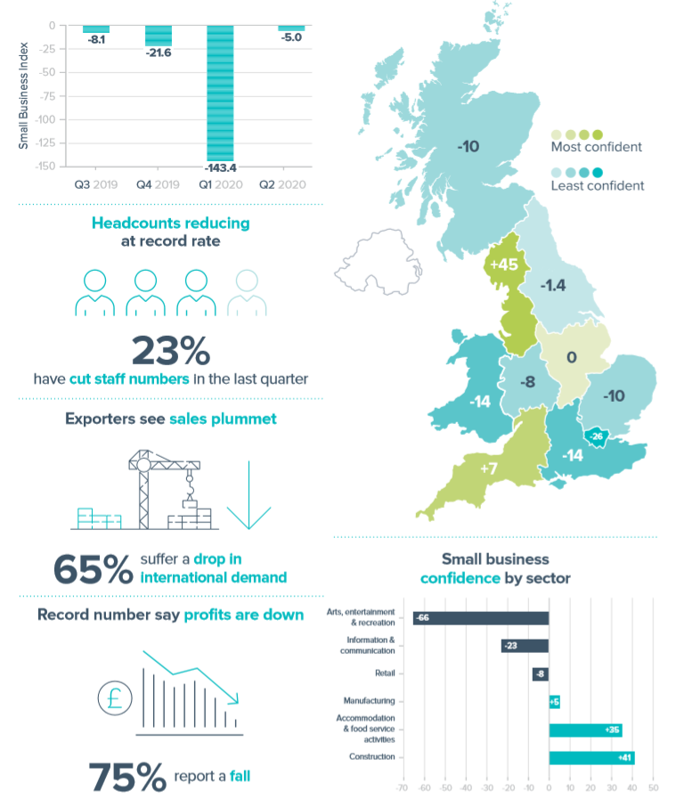
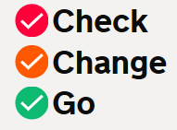
92 days

52%
No risk assessment

